AI Vision and Accelerator framework – template

AI Accelerator key areas

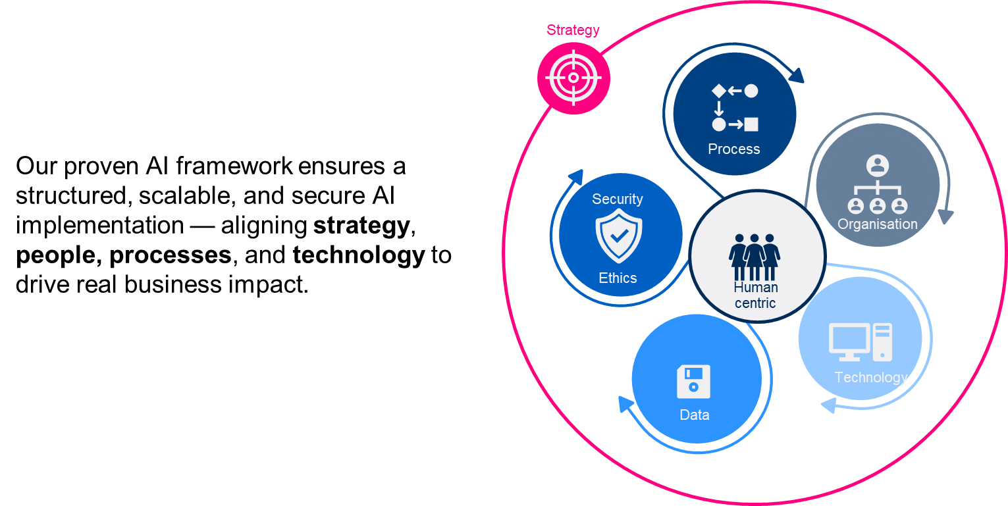
Summarize your AI Vision in 2 – 3 sentences

- Process. What processes, products, or services can be improved with the help of AI? Where can we create the fastest effect to build momentum?
- Organization. Should AI be a support for our employees, an automation engine or a catalyst for new ideas?
How do we want AI to affect our corporate culture and our ways of working? How should we build or develop our AI competence over time?
- Technology. Do we want to build ourselves or buy the technology? How do we want to operate the infrastructure?
- Data. How do we ensure that we have the right data in place? How do we ensure both quality and quantity of data?
- Security and Ethics. What security, privacy, and ethical challenges do we need to address? How do we ensure that AI is used ethically and responsibly?
- People. How do we inspire our employees to feel part of the AI journey? How do we want customers and partners to perceive our AI investment?

